Cognos analytics:

* Analytics on year and yield for valuable insights.

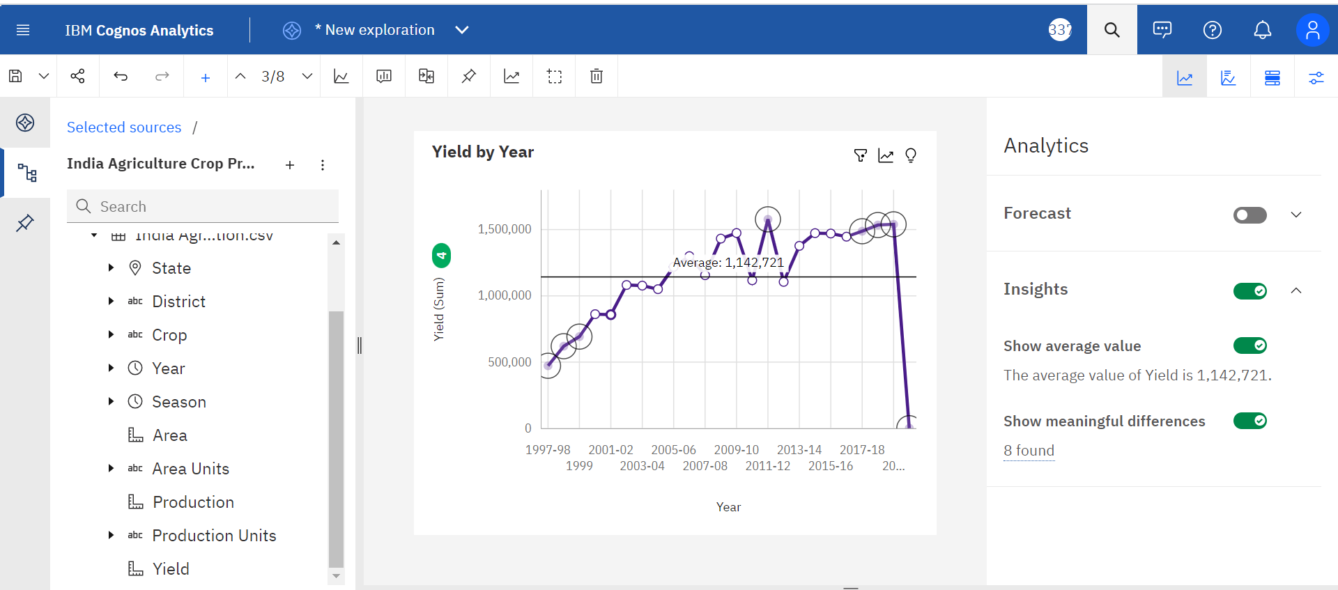

Each detail provided by ibm cognos on analysis of year and yield:

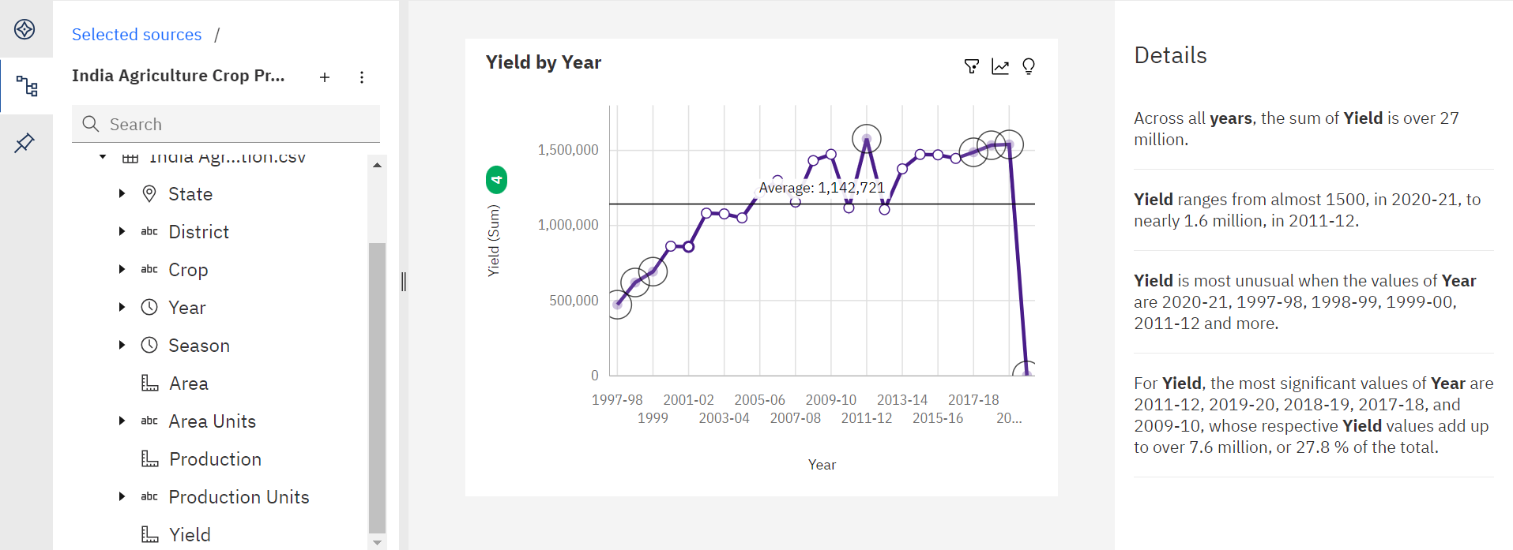



Clear representation of values of yield produced in each year:

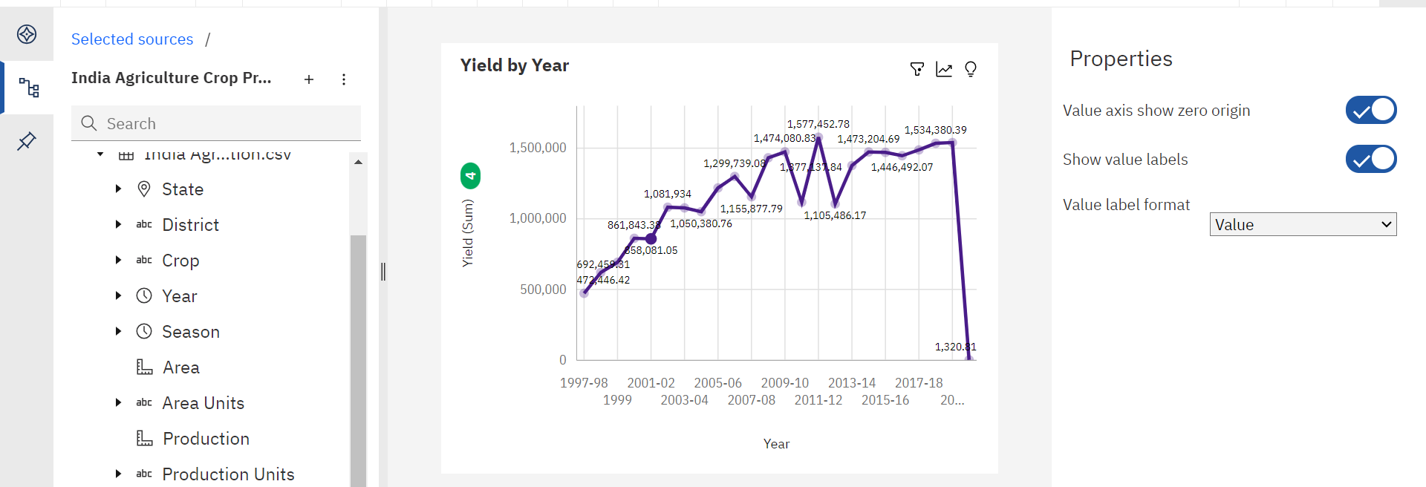

* Analytics on state and their crop production.

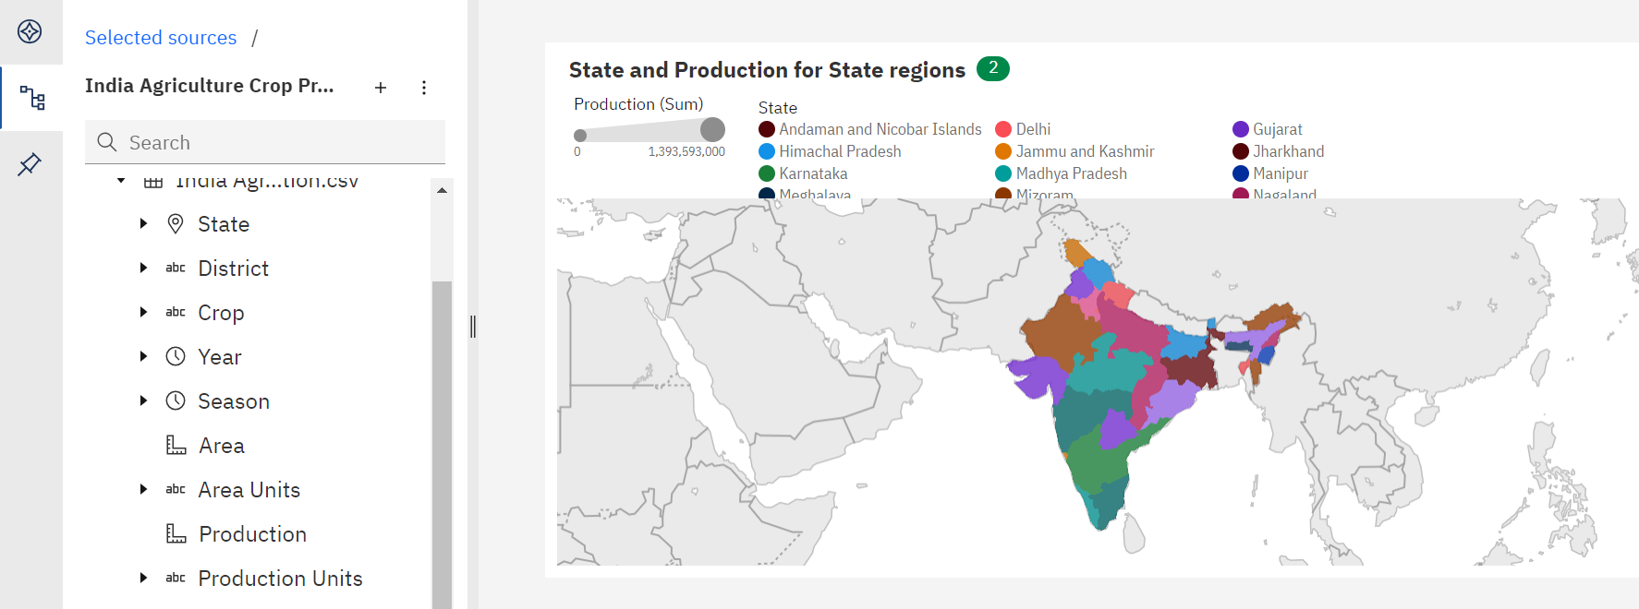

Clear value representation of each state and their crop production:

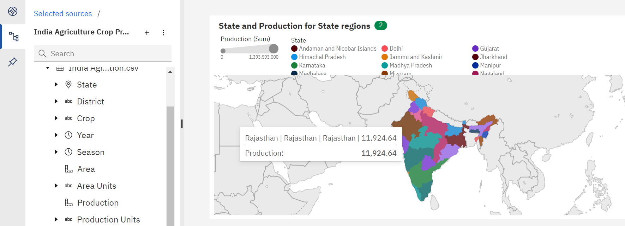

* Analytics on crop and its production as a whole:

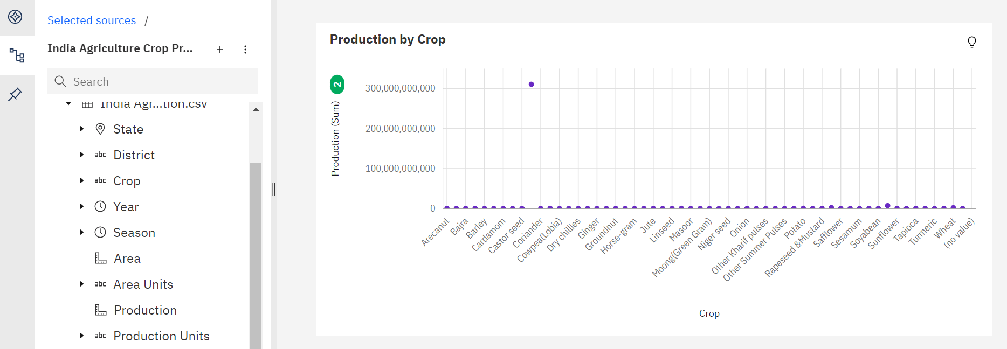

This provides us an insight that unusual high production can be seen with one specific type of crop.